Project Design Document | May/16/2026  Luna Fonseca

Project Concept
1  Player Control |  | You control a  army | in this  top down game
 |  | where  the mouse | makes the player  move and attack

2  Basic  Gameplay |  | During the game,  the enemy’s armies appear | from  the enemy’s base
and the goal of the game is to
destroy every enemy’s structure

3  Sound  & Effects |  | There will be sound effects  of armies clashing, jobs being done, and walking | and particle effects  on building and unit deaths

4  Gameplay  Mechanics |  | As the game progresses,  each player gets more money and bigger armies through their strategy | making it  so that the better strategy wins
[optional] There will also be
worker units that will produce money when mining ore

[optional] There will also be
a castle building that produces worker units

[optional] There will also be
soldier units capable of damaging other units and buildings

[optional] There will also be
a barracks building that produces soldier units

5  User  Interface |  | The  money | will  increase | whenever  a worker unit gathers money
 |  | The  money | will  decrease | whenever  a building or unit is created
 |  | At the start of the game, the title  “Silly Wars” will appear |  | and the game will end when  a player has no structures left

6  Other Features |  | worker units will construct buildings as well.  creating a unit and constructing a building takes time depending on what it is.  There is also fog where units and buildings can’t see.

Project Timeline
Milestone | Description | Due
#1 | - Unit movement | 05/18
#2 | - Unit attacks | 05/25
#3 | - Structure building | 05/29
#4 | - Functional structures & Fog | 05/31
#5 | - Game AI | 06/04
Backlog | - Harder AI / Neural Networks  - More unit types  - More intelligent pathfinding  - Multiplayer | 06/15

Project Sketch
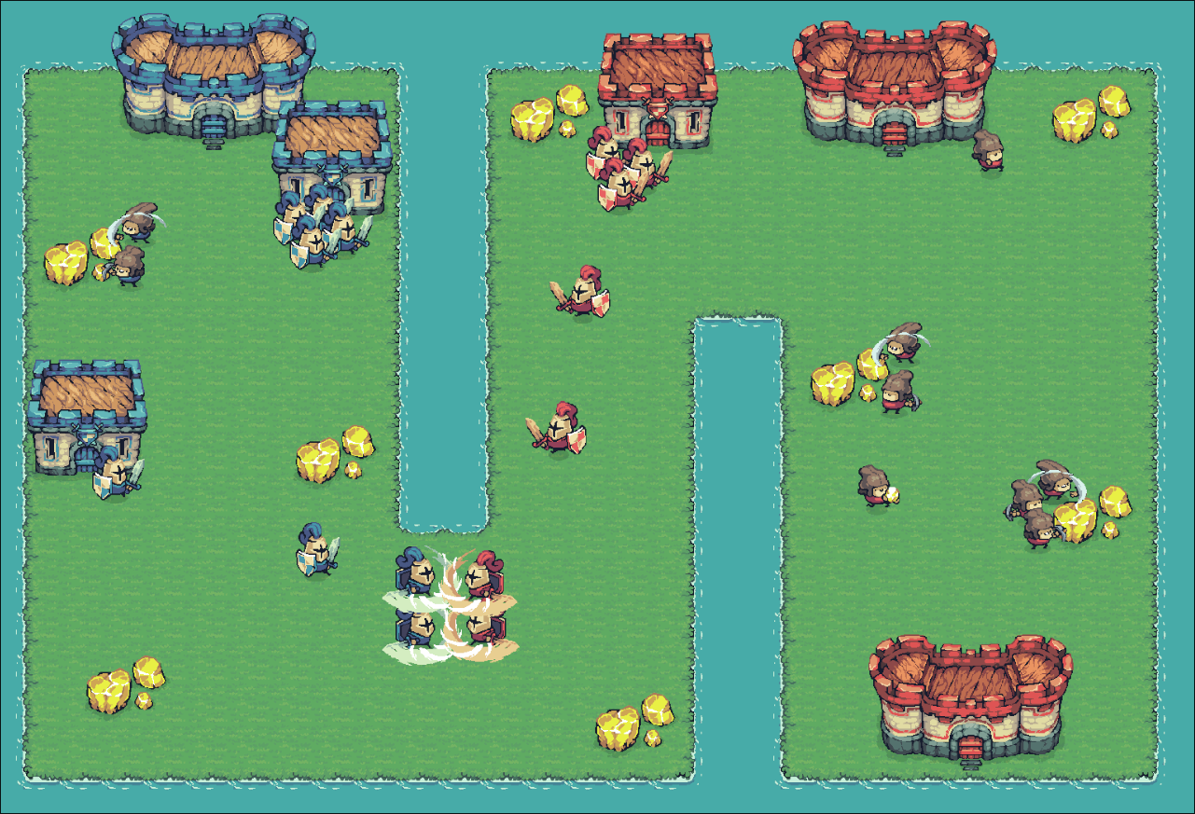
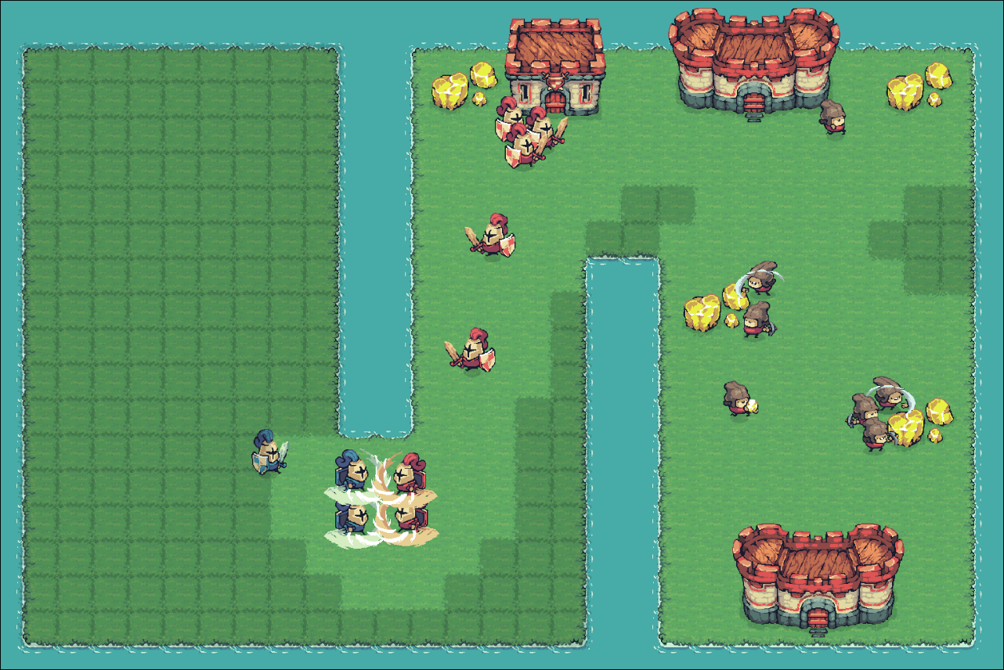
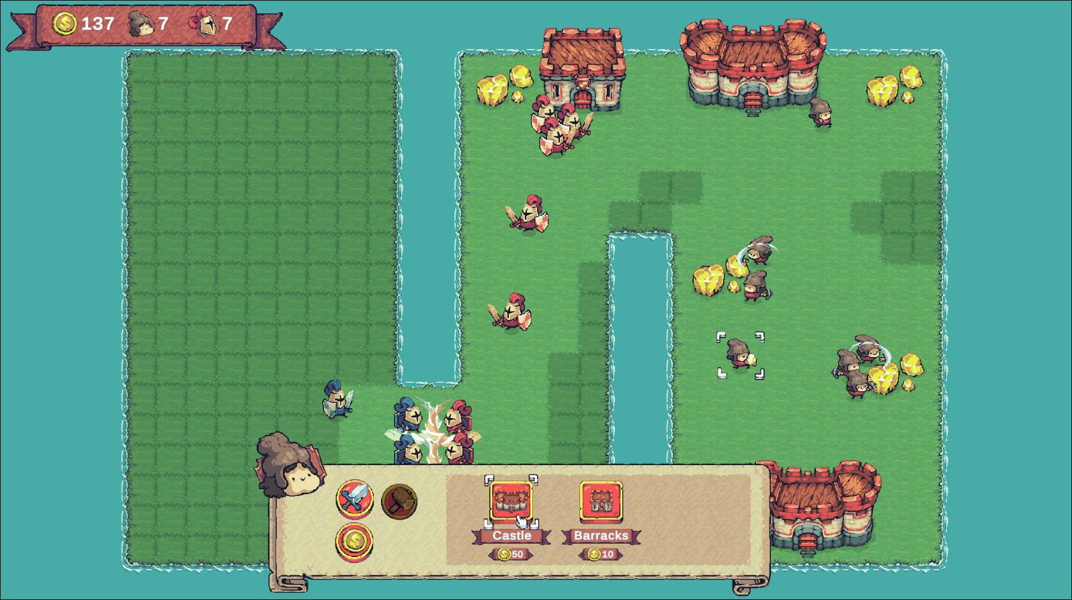
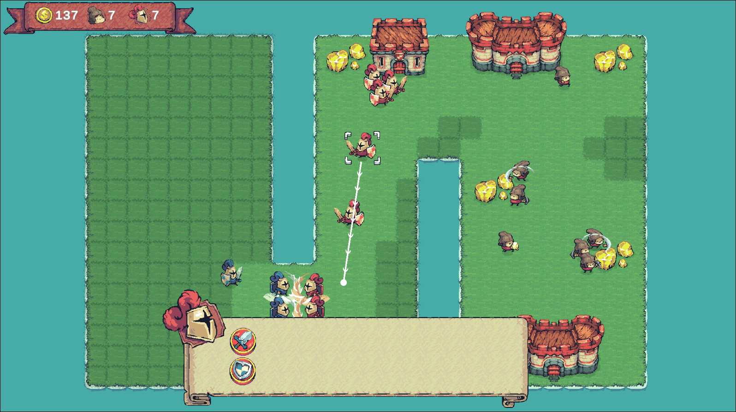

Credits, for each asset or asset library
- Tiny Swords by Pixel Frog, free license for personal and commercial projects. (https://pixelfrog-assets.itch.io/tiny-swords)

